Appendix Figure 1. Selection of Medicare patients discharged to a skilled nursing facility after an acute hospitalization for heart failure
77,670 patients in 11,529 facilities in final analyses
(development cohort: n = 51,783
validation cohort: n = 25,887)
Exclusion criteria:
1,659 patients who had potential predictors with missing data <1%

A random episode for each patient
(n = 79,329 patients in 11,975 facilities)
All episodes of an acute hospitalization (≥3 days of stay) with a primary discharge diagnosis of heart failure in MedPAR file, July 1, 2011 – November 30, 2013
(n = 622,761)
All episodes with a claim for subsequent skilled nursing facility admission on the day of, or day after, the index hospital discharge in the MedPAR file
(n = 228,099)
Exclusion criteria:
83,323 with MDS assessment within 3 months before the index hospitalization;
44,684 without continuous Part A coverage 6 months before and 1 month after the index hospitalization;
14,349 with Medicare Advantage enrollment during the study time frame;
2,387 episodes without 5- day or 14-day MDS assessments where the index SNF stay was more than 14 days
1,264 episodes where first MDS assessment was identified as reentry
138 episodes where patients were comatose or received hospice care
Episodes meeting all inclusion and exclusion criteria
(n = 81,954)

Appendix Figure 2. Calibration curves for observed versus predicted probability of 30-day mortality in the validation cohort
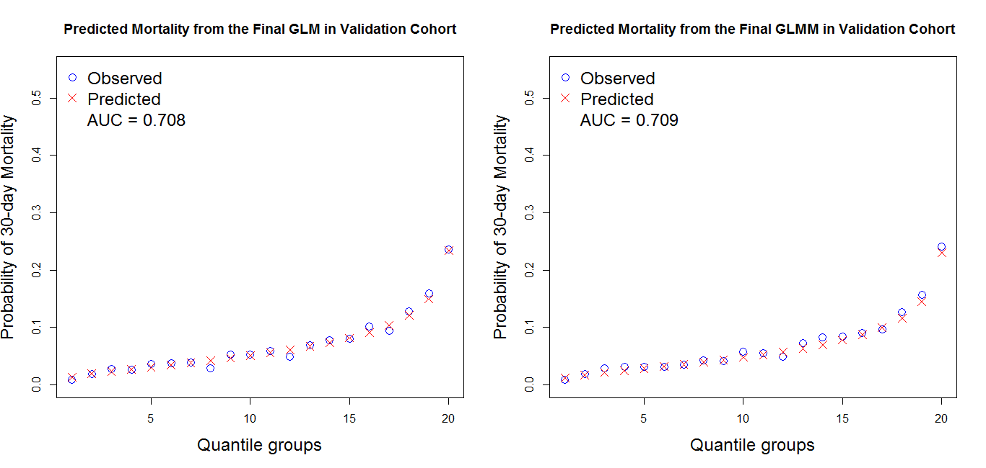
Left: Model 5 for 30-day mortality without random effects of SNFs (GLM = generalized linear model)
Right: Model 5 for 30-day mortality with random effects of SNFs (GLMM = generalized linear mixed model)

Appendix Figure 3. Calibration curves for observed versus predicted probability of 30-day re-hospitalization in the validation cohort
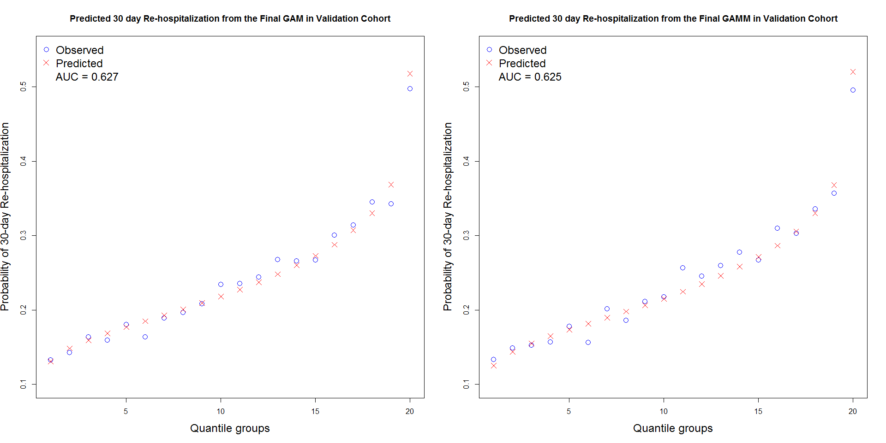
Left: Model 5 for 30-day re-hospitalization without random effects of SNFs (GAM = generalized additive model)
Right: Model 5 for 30-day re-hospitalization with random effects of SNFs (GAMM = generalized additive mixed model)
Appendix Table 1. Facility-level characteristics of the development and validation cohorts
Characteristics, % | Development cohort  (n = 51,783) | Validation cohort  (n = 25,887)
5-star overall quality rating
1 | 10.9 | 11.0
2 | 17.7 | 17.6
3 | 19.9 | 20.0
4 | 29.0 | 28.7
5 | 21.3 | 21.3
Unknown | 1.3 | 1.4
5-star registered nurse staffing rating
1 | 7.9 | 8.6
2 | 15.6 | 15.5
3 | 26.4 | 25.7
4 | 24.9 | 24.5
5 | 21.8 | 22.2
Unknown | 3.4 | 3.5
Certified bed size
< 100 | 34.1 | 34.1
100 – 299 | 54.7 | 55.0
≥ 300 | 11.2 | 11.0
Chain membership
Yes | 56.8 | 56.4
No | 43.2 | 43.6
Profit orientation
For profit | 67.8 | 67.8
Non-profit | 32.2 | 32.2
Geographic location
Urban area | 84.2 | 83.9
Rural area | 15.8 | 16.1
Hours per resident per day of total nursing care
0 - < 3.66 (quartile 1) | 23.2 | 23.4
3.66 - < 4.08 (quartile 2) | 23.4 | 23.1
4.08 -< 4.67 (quartile 3) | 23.8 | 23.4
≥ 4.67 (quartile 4) | 23.5 | 23.7
Unknown | 6.1 | 6.3
Hours per resident per day of licensed nursing care
0 - < 1.39 (quartile 1) | 23.4 | 23.4
1.39 - < 1.62 (quartile 2) | 23.3 | 23.5
1.62 -< 1.94 (quartile 3) | 23.5 | 23.0
≥ 1.94 (quartile 4) | 23.6 | 23.7
Unknown | 6.1 | 6.3
Appendix Table 2. Final predictors for 30-day all-cause mortality
Parameter/Predictor | β-coefficient | SE | p value
Intercept | -5.841 | 0.238 | <.0001
Age | 0.019 | 0.003 | <.0001
Gender (reference: women)
Men | 0.323 | 0.040 | <.0001
Race/Ethnicity (reference: Non-Hispanic white)
Non-Hispanic black | -0.435 | 0.074 | <.0001
Hispanic | -0.452 | 0.124 | 0.0003
Non-Hispanic other | -0.178 | 0.152 | 0.24
Unknown | -0.017 | 0.118 | 0.89
Marital status (reference: Married)
Widowed | -0.062 | 0.044 | 0.16
Separated/divorced | -0.213 | 0.078 | 0.007
Never married | -0.103 | 0.078 | 0.19
Unknown | 0.145 | 0.131 | 0.27
Charlson index (log-transformed) | 0.321 | 0.035 | <.0001
Length of index hospital stay, days (reference: 3-4)
5-6 | 0.063 | 0.051 | 0.215
7-9 | 0.210 | 0.051 | <.0001
10-13 | 0.274 | 0.060 | <.0001
≥ 14 | 0.275 | 0.066 | <.0001
Body mass index, kg/m² (reference: 18.5 - < 25)
< 18.5 | 0.209 | 0.069 | 0.0026
25 - < 30 | -0.205 | 0.045 | <.0001
≥ 30 | -0.505 | 0.051 | <.0001
Unknown | 0.100 | 0.091 | 0.27
Dyspnea | 0.555 | 0.036 | <.0001
Urinary incontinence (reference: continent)
Incontinent | 0.258 | 0.043 | <.0001
Not rated | 0.406 | 0.061 | <.0001
Pressure ulcers | 0.291 | 0.043 | <.0001
Depression severity (reference: none)
Mild | 0.211 | 0.046 | <.0001
Moderate | 0.486 | 0.071 | <.0001
Moderately severe | 0.692 | 0.117 | <.0001
Severe | 0.781 | 0.211 | 0.0002
Unknown | 1.172 | 0.091 | <.0001
Physical limitations (reference: normal or minimal limitation)
Moderate limitation | 0.510 | 0.062 | <.0001
Physical dependency | 0.931 | 0.069 | <.0001
Cognitive function (reference: normal or minimal impairment)
Moderate impairment | 0.226 | 0.043 | <.0001
Severe impairment | 0.482 | 0.053 | <.0001

Appendix Table 3A. Final predictors for 30-day all-cause re-hospitalization where age and Charlson Index were modeled as non-parametric function
Parameter/Predictor | β-coefficient | SE | p value
Intercept | -1.601 | 0.120 | <.0001
Age* | NA | NA | NA
Gender (reference: women)
Men | 0.071 | 0.023 | 0.0021
Race/Ethnicity (reference: Non-Hispanic white)
Non-Hispanic black | 0.032 | 0.036 | 0.38
Hispanic | -0.014 | 0.062 | 0.82
Other | 0.213 | 0.085 | 0.012
Unknown | -0.023 | 0.069 | 0.74
Marital status (reference: Married)
Widowed | -0.020 | 0.026 | 0.44
Separated/divorced | -0.081 | 0.041 | 0.05
Never married | -0.081 | 0.043 | 0.059
Unknown | 0.015 | 0.078 | 0.84
Medicare and Medicaid dual enrollee | 0.021 | 0.029 | 0.47
Charlson index (log-transformed)* | NA | NA | NA
Length of index hospital stay, days (reference: 3-4)
5-6 | 0.127 | 0.029 | <.0001
7-9 | 0.227 | 0.030 | <.0001
10-13 | 0.363 | 0.036 | <.0001
≥ 14 | 0.517 | 0.038 | <.0001
No. of any hospitalizations within 6 months before index hospitalization (ref: 0)
1 | 0.173 | 0.026 | <.0001
≥ 2 | 0.471 | 0.029 | <.0001
Depression severity (reference: none)
Mild | 0.020 | 0.028 | 0.47
Moderate | 0.026 | 0.049 | 0.59
Moderately severe | 0.036 | 0.089 | 0.68
Severe | 0.217 | 0.159 | 0.17
Unknown | 1.673 | 0.069 | <.0001
Physical limitations (reference: normal or minimal limitation)
Moderate limitation | 0.149 | 0.028 | <.0001
Physical dependency | 0.422 | 0.034 | <.0001
*Because age and log-transformed Charlson Index were treated as a non-parametric function using a smoothing spline, parameter estimates were not applicable.

Appendix Table 3B. Final predictors for 30-day all-cause re-hospitalization where age and Charlson Index were modeled as categorical variables
Parameter/Predictor | β-coefficient | SE | p value
Intercept | -1.773 | 0.065 | <.0001
Age, years (reference: <65)
65-69 | 0.038 | 0.064 | 0.55
70-74 | 0.020 | 0.060 | 0.74
75-79 | 0.023 | 0.058 | 0.69
80-84 | 0.003 | 0.056 | 0.96
85-89 | -0.063 | 0.057 | 0.27
90-94 | -0.111 | 0.060 | 0.062
≥95 | -0.285 | 0.072 | <.0001
Gender (reference: women)
Men | 0.082 | 0.023 | 0.0004
Race/Ethnicity (reference: Non-Hispanic white)
Non-Hispanic black | 0.036 | 0.036 | 0.32
Hispanic | -0.011 | 0.062 | 0.86
Other | 0.213 | 0.085 | 0.012
Unknown | -0.023 | 0.069 | 0.73
Marital status (reference: Married)
Widowed | -0.021 | 0.027 | 0.43
Separated/divorced | -0.081 | 0.041 | 0.051
Never married | -0.090 | 0.043 | 0.036
Unknown | 0.014 | 0.078 | 0.86
Medicare and Medicaid dual enrollee | 0.023 | 0.029 | 0.44
Charlson index (reference: 1-4)
5-7 | 0.211 | 0.024 | <.0001
>7 | 0.270 | 0.0426 | <.0001
Length of index hospital stay, days (reference: 3-4)
5-6 | 0.132 | 0.029 | <.0001
7-9 | 0.238 | 0.030 | <.0001
10-13 | 0.376 | 0.036 | <.0001
≥ 14 | 0.533 | 0.038 | <.0001
No. of any hospitalizations within 6 months before index hospitalization (ref: 0)
1 | 0.194 | 0.025 | <.0001
≥ 2 | 0.506 | 0.029 | <.0001
Depression severity (reference: none)
Mild | 0.023 | 0.028 | 0.41
Moderate | 0.027 | 0.049 | 0.58
Moderately severe | 0.036 | 0.089 | 0.68
Severe | 0.216 | 0.159 | 0.18
Unknown | 1.669 | 0.069 | <.0001
Physical limitations (reference: normal or minimal limitation)
Moderate limitation | 0.151 | 0.028 | <.0001
Physical dependency | 0.424 | 0.034 | <.0001

Appendix Table 4. Area under receiver operating characteristic curves (AUCs) for 30-day mortality and 30-day re-hospitalization in sensitivity analyses
Sensitivity analyses | Predictors | Mortality: AUCs (95% CI) |  | Re-hospitalization: AUCs (95% CI)
 |  | Development Cohort | Validation Cohort | Development Cohort | Validation Cohort
Original study population | All predictors* associated with the outcomes and increased AUC | 0.729  (0.721-0.738) | 0.727  (0.715-0.739) | 0.650  (0.644-0.655) | 0.642  (0.634-0.650)
Completed cases without missing data | Predictors in final models | 0.702  (0.692-0.711) | 0.702  (0.689-0.715) | 0.623  (0.617-0.629) | 0.621  (0.612-0.629)
Patients aged ≥ 65 years | Predictors in final models | 0.704  (0.695-0.712) | 0.707  (0.694-0.719) | 0.625  (0.620-0.631) | 0.623  (0.615-0.632)
Men | Predictors in final models except gender | 0.711  (0.699-0.724) | 0.686  (0.667-0.704) | 0.619  (0.611-0.628) | 0.620  (0.607-0.632)
Women | Predictors in final models except gender | 0.693  (0.681-0.706) | 0.713  (0.696-0.730) | 0.629  (0.622-0.637) | 0.627  (0.616-0.638)
Patients survived 30 days after SNF admission | Predictors in final models | NA | NA | 0.627  (0.621-0.634) | 0.623  (0.615-0.632)
* For 30-day all-cause mortality, in addition to the predictors in the final model, the newly added predictors included type of heart failure, hypertension, coronary artery disease, atrial fibrillation, hyperlipidemia, diabetes, anemia, chronic kidney disease, depression, pneumonia, number of hospitalizations for heart failure and number of any hospitalizations in the 6 months before the index hospitalization, fall history in the month before the index SNF admission, pain, individual activity for eating, dressing, using the toilet, bathing, getting in and out of bed, and locomotion on unit, separately, as well as the facility-level factors (5-star nursing staffing rating, certified bed size, and geographic location); The Hosmer and Lemeshow test p = 0.56 in the development cohort.
For 30-day all-cause re-hospitalization, in addition to the predictors in the final model, the newly added predictors included type of heart failure, hypertension, coronary artery disease, atrial fibrillation, hyperlipidemia, diabetes, COPD/asthma, anemia, chronic kidney disease, dementia, depression, pneumonia, number of hospitalizations for heart failure and for other heart disease in the 6 months before the index hospitalization, separately, use of intensive unit care during the index hospitalization, BMI, dyspnea, urinary incontinence, fall history in the month before the index SNF admission, pressure ulcer, individual activity for eating, dressing, using the toilet, bathing, getting in and out of bed, and locomotion on unit, separately, as well as the facility-level factors (5-star nursing staffing rating, certified bed size, chain membership, profit orientation, geographic location, hours per resident per day of total nursing care, and hours per resident per day of licensed nursing care); The Hosmer and Lemeshow test p = 0.11 in the development cohort.

