Supplemental Figure 1: English translation of the questionnaire sent to long-term care facilities.
Directors and medical directors were asked to state if each measure was applied on the following basis (unless otherwise mentioned):
- No, never
- Yes, but insufficiently
- Yes, regularly
- Yes, always
Staff:
- Alcohol-based hand rub (ABHR) is performed when entering premises.
- A face mask is worn when entering premises.
- ABHR is performed when entering changing rooms.
- Physical distancing and maximal room occupancy are applied in changing rooms.
- ABHR is performed before starting work.
- Upper surfaces sanitizing is performed at least twice daily in all departments (e.g. computer keyboard).
- Adequate ventilation is performed at least twice daily in all departments.
- Adequate personal protective equipment (PPE) is worn following prescription for care to isolated residents.
- Adequate PPE is available at all times for all staff when caring for residents with suspected COVID-19.
- Physical distancing and touch avoidance (PDTA) are applied with residents whenever possible.
- PDTA are applied with other staff members whenever possible, including during breaks.
- PDTA are applied with visitors.
- Physical distancing and maximal room occupancy are applied in elevators.
- Staff change clothes before and after their meal break times.
- ABHR or hand washing is performed before and after all break times.
- Break times are arranged to allow for PDTA (place and time schedule).
- Break rooms and amenities (e.g. microwave oven, coffee machines) are sanitized after all meals
- Personal food stored in shared refrigerators is wrapped in individual plastic bags.
- Face masks are taken off after leaving premises.
- ABHR is performed when leaving premises.
- Night teams follow all abovementioned measures.
- Dedicated COVID-19 units are implemented after three residents or more are rested positive.
- Exceptional procedures are designed to face absenteeism up to 40%.
- Infection prevention and control (IPC) procedures in case of epidemics are protocoled.
- IPC procedures in case of epidemics are known by staff.
- IPC procedures in case of epidemics are applied by staff.
- PPE stocks are monitored.
- COVID-19 testing procedures are protocoled and are known by staff.
- Occupational medicine services are available to staff.
- Unformal staff support is available if no occupational medicine service is available to staff.
- A crisis unit meets on a weekly basis.
- Staff are rapidly informed of new measures decided by the crisis unit.
- COVID-19 prevention plan included external care providers’ interventions.
- IPC procedures are defined in collaboration with external IPC support teams.
- Physical distancing during mealtimes and break times is at least one meter.
- Staff cohorting is implemented in dedicated COVID-19 units.
- Physiotherapists always wear N95 masks when with residents (yes/no question).
- Staff wear N95 during prolonged oral or pharyngeal care.
Entrance
- Visitors and staff have separate entrances.
- Visitors can leave clothes or personal belongings in a safe closet.
- Entry and exit paths are physically separated or delimited by floor markings.
- Reception area is disinfected.
External care providers
- ABHR is performed when entering premises.
- A face mask is worn when entering premises.
- PDTA are applied with residents whenever possible.
- PPE is available in case of COVID cases.
- Professional equipment is made available to visiting physicians (e. g. stethoscope)
- Professional equipment is disinfected after each use.
- Consultations take place in resident’s room or in a dedicated room.
- Residents’ escort outside to take ambulances is protocoled.
- Disinfection of computers made available to external care providers is protocoled.
- External care providers signed a dedicated convention.
- Face masks are taken off after leaving premises.
- ABHR is performed when leaving premises.
- External care providers’ rotations are scheduled.
Visitors
- ABHR is performed when entering premises.
- A face mask is worn when entering premises.
- PDTA are applied with residents.
- A face mask is worn at all times of the visit.
- Community volunteers signed a dedicated convention.
- Face mask is taken off after leaving premises.
- ABHR is performed when leaving premises.
- Exterior reception is organized (e. g. tent)
- Visits are upon reservation only.
Group activities
- ABHR is performed when entering premises.
- A face mask is worn when entering premises.
- ABHR is performed when beginning activities.
- PDTA are applied with residents.
- PDTA are applied with participating residents whenever possible.
- Physical distancing and maximal room occupancy are applied in elevators.
- Activities are organized with fixed groups of maximum five residents.
- The surface of activities rooms and break time rooms is at least 4m² per resident.
- Face mask is taken off after leaving premises.
- ABHR is performed when leaving premises.
Laundry service
- ABHR is performed by laundry staff before service.
- Laundry staff wear PPE when handling laundry from residents with COVID.
- PDTA are applied.
- Laundry from COVID-positive residents is placed in hydro soluble bags before being placed in clearly identified specific bags.
- External laundry services use hydro soluble bags.
Dining hall
- ABHR is performed by dining hall staff before service.
- Dining hall staff enforce residents’ ABHR before meals and snacks.
- PDTA are applied with residents.
- Dining hall entry and exit paths allow for physical distancing.
- PDTA are applied between residents during meals.
- Recommended hygiene measures are followed when handling water bottles and trays.
- A N95 mask is worn by dining hall staff when assisting COVID-negative and COVID-positive residents during their meals.
Other
- Oxygen supplementation systems are monitored.
- A physician is identified as COVID-referent in case no medical director is employed.
- Access to external medical or non-medical human resources is possible if needed.
- Knowledge of contact details for the local COVID support team and of its missions.
- Knowledge of contact details for the on-call palliative care team and its missions.
- Knowledge of procedure for hospital-at-home admission.
- Knowledge of available geriatric mobile teams.
- Knowledge of hospital departments with possible direct admission.
- Easy access to IPC support teams.
- Knowledge of a regional support platform to human resources.
- Knowledge of the regional platform website.
- Anticipation of the modalities for setting up a unit dedicated to COVID-positive residents.
- Staff’s knowledge of protocols of care to COVID-positive residents.
- Re-admissions from hospitalization are conditioned to a preliminary PCR test.
- Re-admissions from hospitalizations are followed by a 7-day quarantine.

Supplemental Figure 2: The ten most important variables as identified the random forest model on the number of residents’ deaths, and percentage increase in mean square error (%IncMSE).
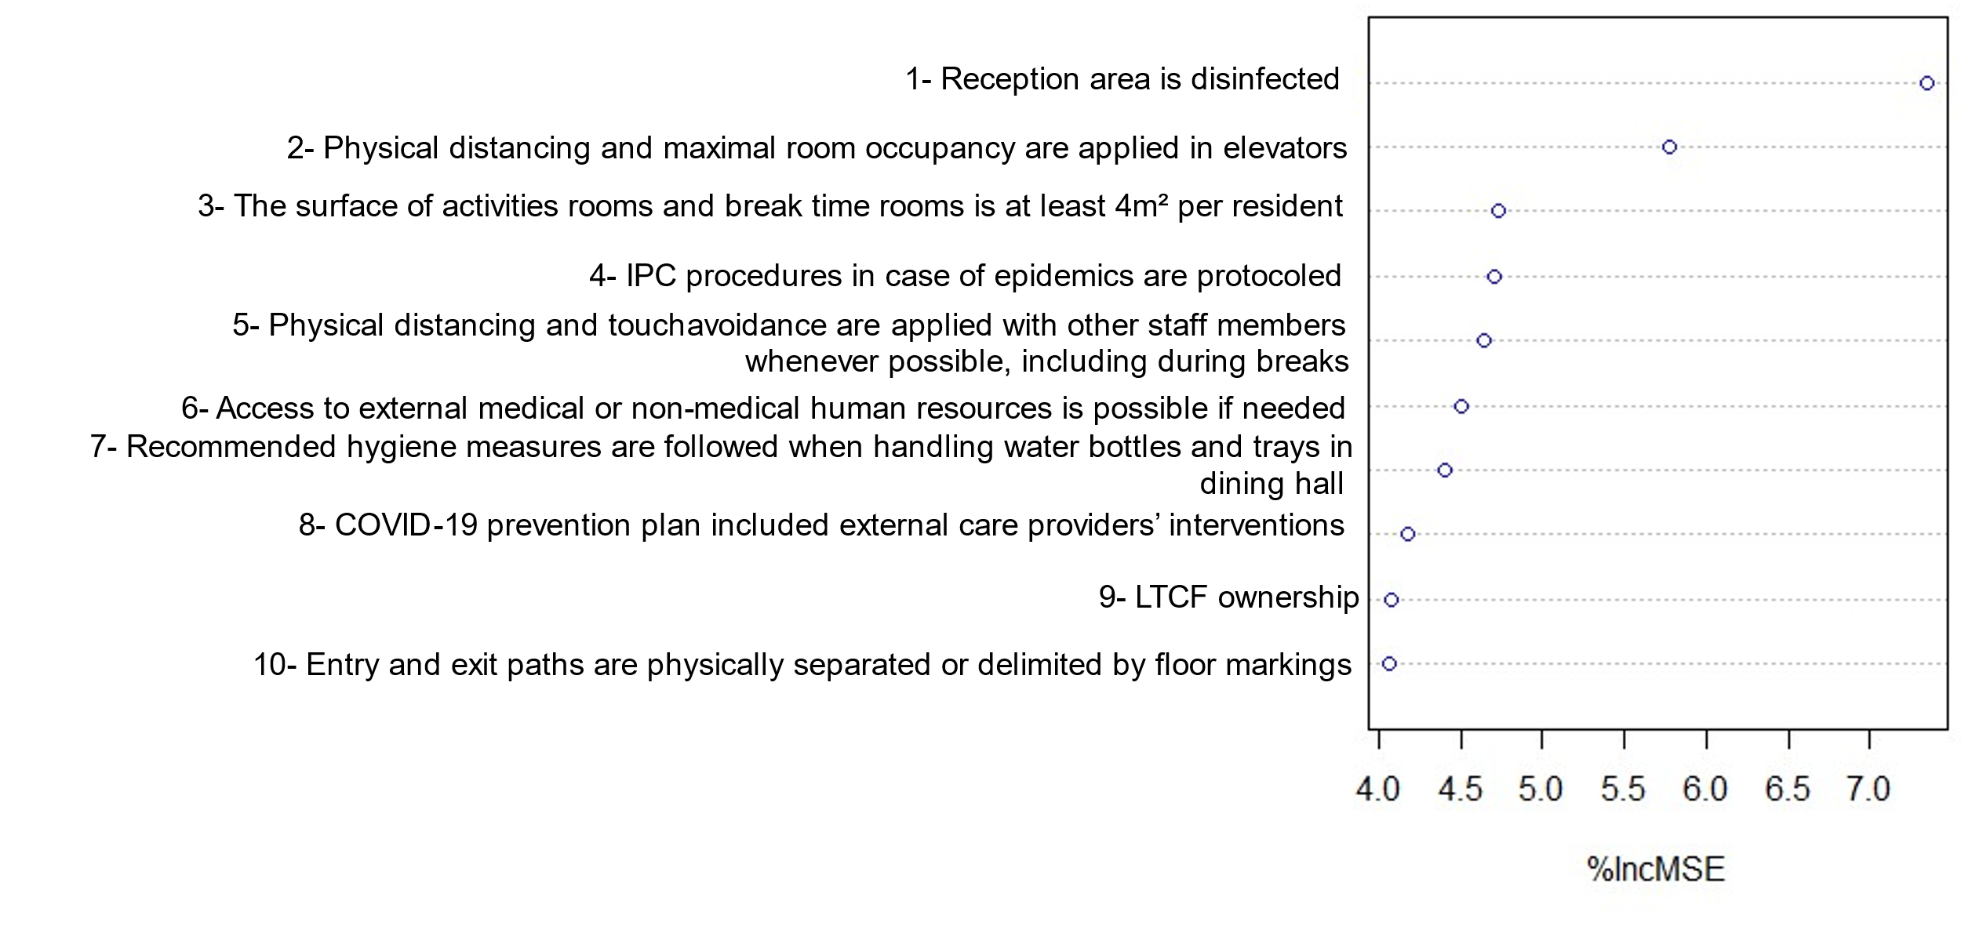
Supplemental Figure 3: The ten most important variables as identified the random forest model on the number of residents’ cases, and percentage increase in mean square error (%IncMSE).
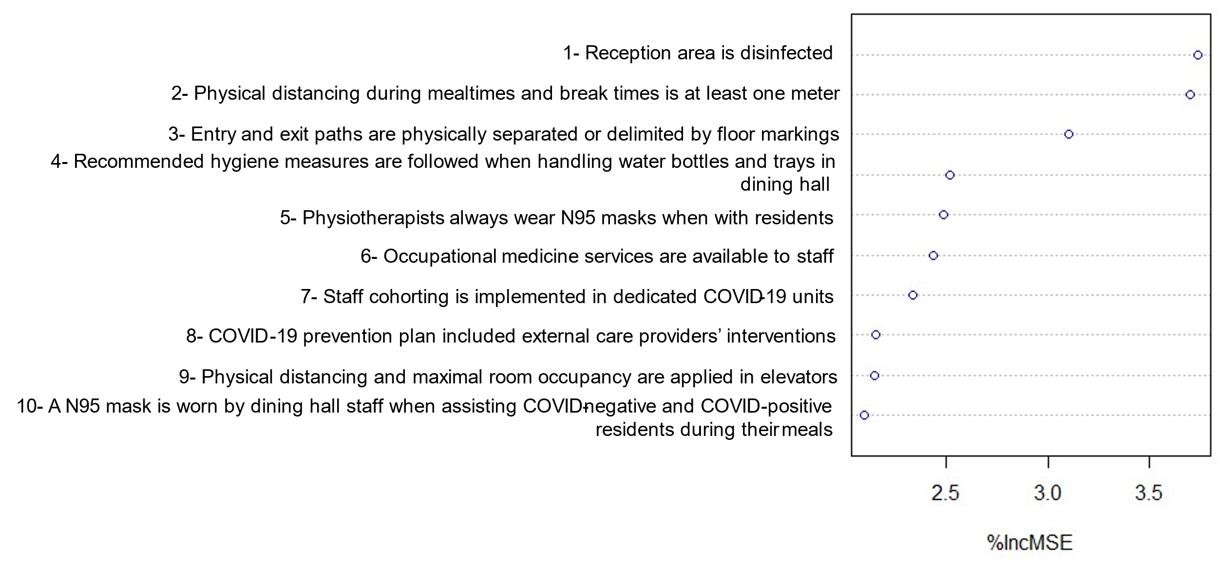
Supplemental Figure 4: The ten most important variables as identified the random forest model on the number of HCP cases, and percentage increase in mean square error (%IncMSE).
