Supplementary Material

Table S1. Description of anticholinergic agents
International Non-proprietary Name (INN) | Frequency (%)
ADS Score 1
Furosemide | 194 (28.95)
Oxazepam | 68 (10.15)
Tramadol | 49 (7.31)
Paroxetine | 43 (6.42)
Alprazolam | 35 (5.22)
Clonazepam | 25 (3.73)
Lorazepam | 24 (3.59)
Warfarin | 22 (3.28)
Fentanyl | 19 (2.84)
Diltiazem | 17 (2.54)
Valproate | 17 (2.54)
Fluoxetine | 14 (2.09)
Clorazepate | 12 (1.79)
Olanzapine | 11 (1.64)
Prednisone | 10 (1.49)
Sertraline | 9 (1.34)
Diazepam | 5 (0.75)
Loperamide | 5 (0.75)
Prednisolone | 3 (0.45)
Hydrocortisone | 2 (0.30)
Nifedipine | 2 (0.30)
Oxycodone | 2 (0.30)
Dexamethasone | 2 (0.30)
Azathioprine | 1 (0.15)
Bromocriptine | 1 (0.15)
Captopril | 1 (0.15)
Triamcinolone | 1 (0.15)
ADS Score 2
Carbamazepine | 8 (1.19)
Loxapine | 2 (0.30)
Ranitidine | 1 (0.15)
ADS Score 3
Hydroxyzine | 24 (3.58)
Amitriptyline | 16 (2.39)
Oxybutynine | 9 (1.34)
Clomipramine | 8 (1.19)
Trihexyphenidyl | 6 (0.90)
Clozapine | 1 (0.15)
Imipramine | 1 (0.15)

Abbreviation: ADS: Anticholinergic Drug Scale
Table S2. Tolerance – Final model (N=499)

Patients characteristics | Tolerance
ADS (ref=0)  1–2  ≥ 3 | 0.73  0.73
Women vs men | 0.92
Charlson score (ref=0)  1–2  ≥ 3  unavailable | 0.55  0.53  0.65
History of fracture (yes vs no) | 0.94
MMSE score (1 point of increase) | 0.84
Abnormal one-leg standing balance test vs normal | 0.81
QOL-AD score (1 point of increase) | 0.88
GIR score (1 point of increase) | 0.70

Abbreviations: ADS: anticholinergic drug scale; OR: Odds Ratio; CI: Confidence Interval; MMSE: Mini Mental State Examination; QOL-AD: Quality of Life in Alzheimer’s Disease; GIR (Groupe Iso-Ressources)

Table S3. Multivariate analysis – Sensitivity Analysis model (N=499) – Variable of interest (ADS score) and variables already associated with malnutrition in the literature

Patients characteristics | OR | 95% CI | p-value
ADS (ref=0)  1–2  ≥ 3 | 0.88  0.93 | [0.54 – 1.43]  [0.49 – 1.76] | 0.591  0.824
MMSE score (1 point of increase) | 0.95 | [0.91 – 0.99] | 0.023
QOL-AD score (1 point of increase) | 0.90 | [0.86 – 0.94] | < 0.001
GIR score (1 point of increase) | 0.60 | [0.50 – 0.72] | < 0.001

Abbreviations: ADS: anticholinergic drug scale; OR: Odds Ratio; CI: Confidence Interval; MMSE: Mini Mental State Examination; QOL-AD: Quality of Life in Alzheimer’s Disease; GIR (Groupe Iso-Ressources)

Figure S1. Number of residents according to Mini Nutritional Assessment scores (N=585)
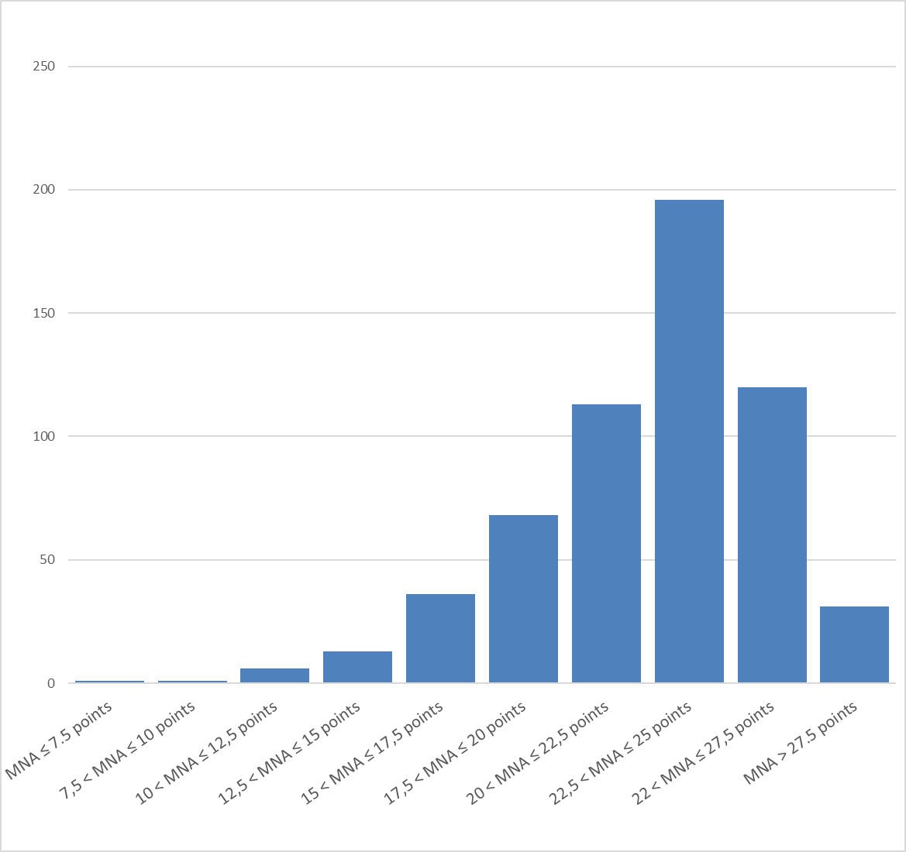

Abbreviation: MNA: Mini Nutritional Assessment

